B37VB

Edinburgh

Robotics

Group 13

Final Report

**Contact Details:**

Fraser Rillie

H00468608

[fcr4000@hw.ac.uk](mailto:fcr4000@hw.ac.uk)

Taylor Smyth

H00470749

Ts4002@hw.ac.uk

Revision History

|  |  |  |  |
| --- | --- | --- | --- |
| Version Number | Date | Author Name | Notes |
| #1 | 02/04/2025 | Taylor Smyth | Basic Formatting with start to each section |
| #2 | 03/04/2025 | Fraser Rillie | First draft of whole report |

Table of Contents

Introduction 2

Theory of Operation 3

Light Tracking Algorithm 3

Method 3

Results 4

Conclusion 4

References 4

# Introduction

In the lab, a robot buggy was provided with which a microcontroller (Arduino), using two Light Dependent Resistors (LDR) that we built onto the breadboard, which is fixed onto the buggy, creating a closed loop system. The goal of the labs was to have the buggy move autonomously to follow the light shone onto the LDRs. The circuit used threshold values that are static, which means that if the LDR threshold value is surpassed, due to an increase in light intensity, the robot will turn to face, then follow the light.

# Theory of Operation

The buggy acts based on the data received from the LDRs. Two LDRs are fixed onto the buggy, correlating to either a Left or Right motor. Analogue values are taken from both LDRs, which will then be compared. The analogue values change based on the luminosity of the light shone on to an LDR, so if the value changes, the corresponding motor should either slow down or speed up depending on if the value increases or decreases.

The way the motors change is through an H-bridge driver, which can change the polarity (changing between forward and back) and the speed which is through PWM (pulse width modulation).

# Light Tracking Algorithm

In the code supplied in the repository, the threshold for the difference in LDRs is 100. If this threshold is surpassed, the PWM of the corresponding motor will change. The reason that the threshold is 100, is to make sure the buggy will not react to the ambient light of the room, shadows of objects or people within the room. This is how the “turn now” determination is made. If it is under this or equivalent to each other, the buggy will go straight.

The initial PWM values in the code are 153 for the left motor, and 140 for the right motor. This is to ensure the buggy will go in a straight line while the LDR values are under the threshold. For turning left, the Left Motor PWM is 100 and the Right Motor PWM is 200. This is vice versa for turning left.

# Method

Mentioned in the theory section of the report, the initial PWM values for the Left and Right motors are 153 and 140. However, when initially provided the values were both 150, which had to be changed due to an observation made. The buggy clearly veered off instead of going in a straight line. This was fixed by adjusting the PWM to 153 and 140 to correct this.

To measure the variation of voltage based on the light detection of the LDRs, an LDR within a voltage divider, had its output connected to an analogue input. By changing the illumination enacting onto the LDR we can read the voltage output.

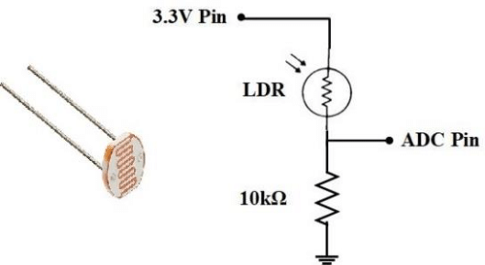

Figure 1. Example of an LDR in a voltage divider circuit

An oscilloscope was used to find the voltage variation of the LDR in different illuminations. The following three intensities were tested:

* No Light
* Room Light
* Torch Light

# Results

|  |  |  |
| --- | --- | --- |
| Test Number | Light Intensities | Voltage Output |
| 1. | No Light | ~ 0V |
| 2. | Room Ambient Light | ~ 2.5V |
| 3. | Torch Light | ~ 5V |

These results clearly show that the voltage output increases as the light intensity increases, which means that the circuit created is working as it is supposed to.

# Conclusion

Implementing all the data found in the labs, the goal for the buggy was completed, as it followed light successfully in reference to the varying levels of light intensity for each LDR. It was critical for the initial PWM values for straight line were changed, as the buggy would steer in one direction if not changed. The voltage divider was tested to make sure the issue wasn’t in our implementation, but rather a hardware issue within the motors, or possibly even inequal traction in both wheels. The use of the H-Bridge helped with quick responses to light changing, which allowed the buggy to follow the light with much success.

The main thing, which was found critical for the lab, was to make sure that the motors and LDRs were properly calibrated to ensure effective control of the robot.

# References

1. Research Gate - “Design of an Ultra-Low Powered Data-Logger for Stand-Alone PV Energy Systems” - Asif Ur Rehman, M. Tariq Iqbal – December 2020

<https://www.researchgate.net/figure/Light-dependent-resistor-and-a-voltage-divider-to-sense-light-intensity_fig6_348189685>